**Task 1:**

**# Project Description**

**## GitHub Repo**

```

git@github.com:metcs/met-cs665-assignment-3-Sherry-Gin-XwY.git

```

**## 1. Application Description**

A company has different types of customers, like Business, Returning,  Frequent, New and VIP.

The management of the company needs tp send customer specific emails to their customers. They

would need to have an application that generates emails from a base template for different types of

customers.

In this assignment, you will implement this "E-MailGeneration" Application for email auto-

generation based on specific customer types.

**## 2.1 Implementation Description**

This is my design for the assignemnt 3 E-mail generation system. I would like to use the Factory Pattern which is very easy way to implement it.

Email is a class which provide some method to change their own data, and other different type of email which can use this email template to update their message.

the email generator will going to create a new email depends on which type of email it going to create, and update the email template.

* How flexible is your implementation, e.g., how you add or remove in future new email type?

* Answer: I can just create a new class and defined which kind of email it is, edit the template, and add it to the EmailGeneration.java, Since it just use new class to update the Email template, which it is very simple to add or remove email type.

*

* How is the simplicity and understandability of your implementation?

* Answer: Please see the attached UML diagram to see how does the System looks like. it is very simple to understand it.

*

* How do you avoid duplicated code?

* Answer: Some duplicated code which need to setup different template of the email, but I think the main email template is very clear.

**Task 2:**

**## 2.2 UML-Diagram**

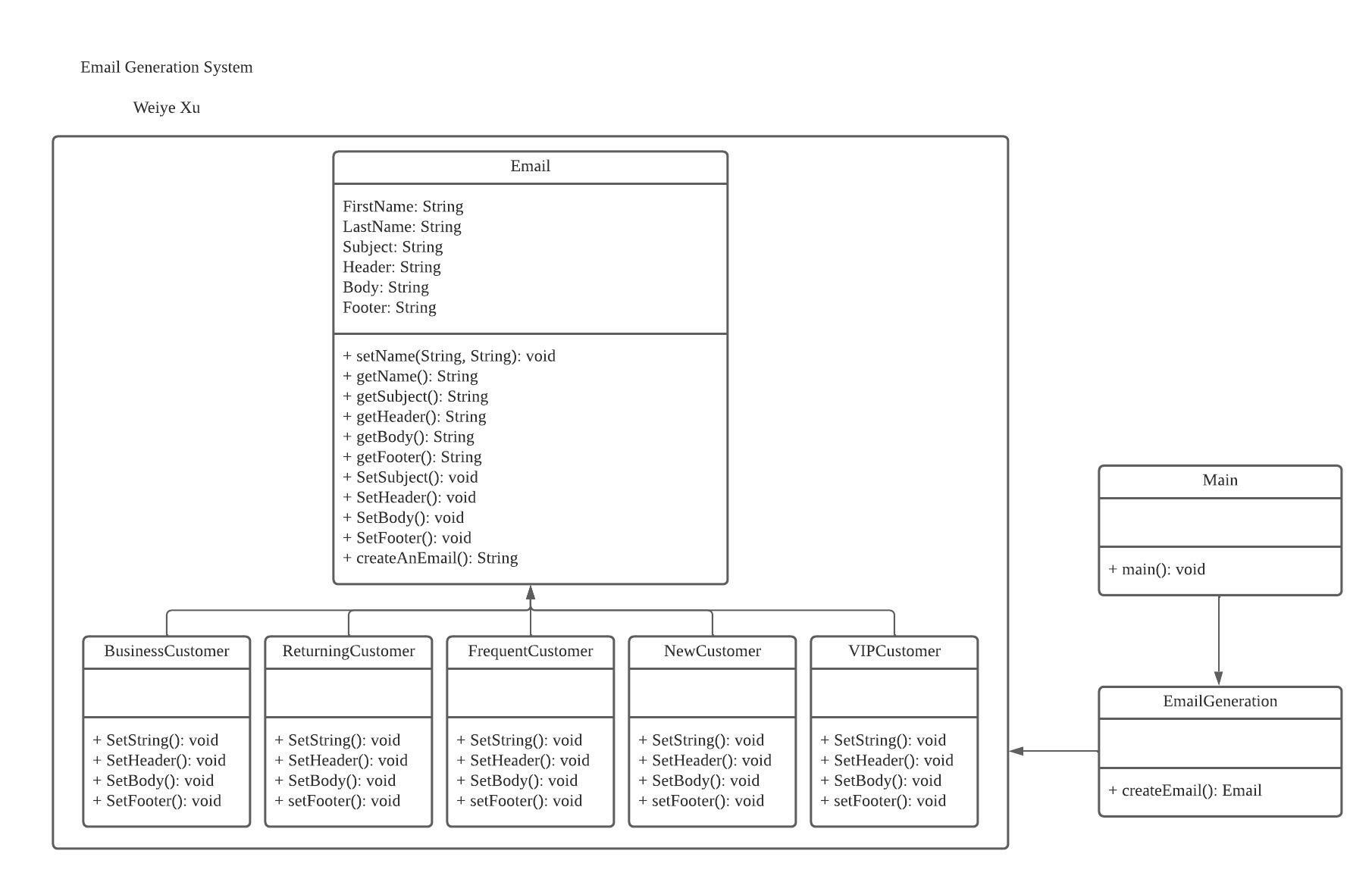

Task3:

mvn clean compile

mvn clean compile assembly:single

mvn -q clean compile exec:java -Dexec.executable="edu.bu.met.cs665.assignment3.Main" -Dlog4j.configuration="file:log4j.properties"

mvn clean compile test checkstyle:check spotbugs:check

